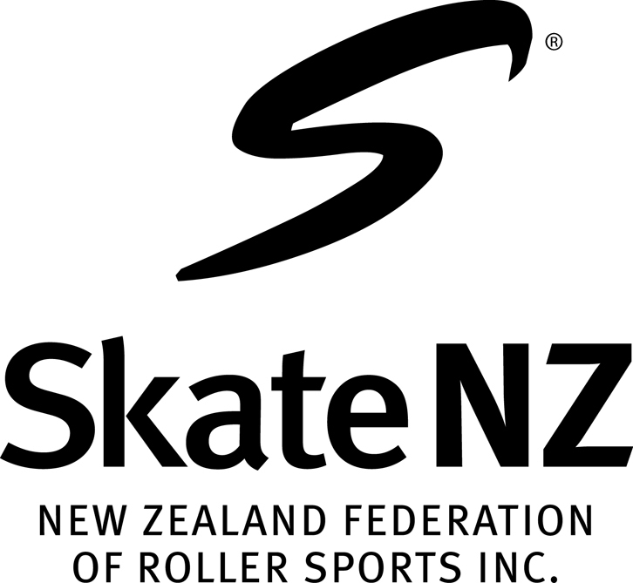
CENTRAL AREA ROLLER SPORTS COMMITTEE

CENTRAL AREA ROLLER SPORTS CHAMPIONSHIPS
PALMERSTON NORTH 10,11,12th May, 2019
Dear Club Secretary,

We enclose Area Championship entry forms for your club. Please ensure you return these on or before closing date of entries. Due to major changes to the current National Schedule this year please ensure that each skater enters the correct grade, has a current SkateNZ registration number and a current Artistic number. Please ensure your members are aware that they need to be prepared to stay 2 nights. With the number of extra events this year and Rollart Judging requirements events will probably to commence Friday morning.
Entry Forms
There is entry form for each skater for each discipline. Please fill these out clearly, preferably by printing. There is also a Master Sheet for each club to be filled in with all your competitors names, in surname alphabetical order please, plus the total cost of your clubs entry fees and return with entry forms and cheque. Money may also be debited to the TSB account below. We also require indication if a skater is planning to attend NZ Championships. If posting remember to allow 5-7 days or more for them to be received.

Entry Fees – $50 per skater for one event; $70 per skater for 2 or more events

Entries close – 1st April, 2019 (LATE ENTRIES WILL NOT BE ACCEPTED.)
with Central Area Secretary. Mrs Val Bedford,
10 Kennedy Place, New Plymouth, 4312
Telephone 06 7586233. E. Mail – Sheryll.valb@xtra.co.nz

Please make cheques out to West Central Region
Money may be direct debited to TSB Bank 153950 0229267 00 please tag with club name.

PROGRAM ELEMENT SHEETS
Please ensure that skaters entering World Skate aligned events submit their programme Element Sheets with their entry forms. (see Art News Flash 21/2/19 for forms)

DISPENSATION FORMS – Please use the one attached as it has been collated as one page, making it easier for use. Fill in as required. These must be sent with entries forms. Late Medical dispensations will be accepted up to the day.

Club Team Manager – Remember you are required to elect a Team Manager for your club. A meeting will be held prior to the commencement of Areas. See separate sheet for their requirements/duties.

Area Rules – Please ensure that all skaters, parents and coaches are aware of the information contained in “Important Notice to Clubs”, especially regarding sending music prior.

Proposed Programme - We will endeavour to have a programme to clubs approximately 10 days after entries close. Please be aware that NO CHANGES will be made to this programme. Club Roster for Officials Food will be included with this programme

National Entry Forms – National entry forms need to be handed in at Area Championships due to the short time between closing date and Area Championships.
1/3/19

