30/07/2026

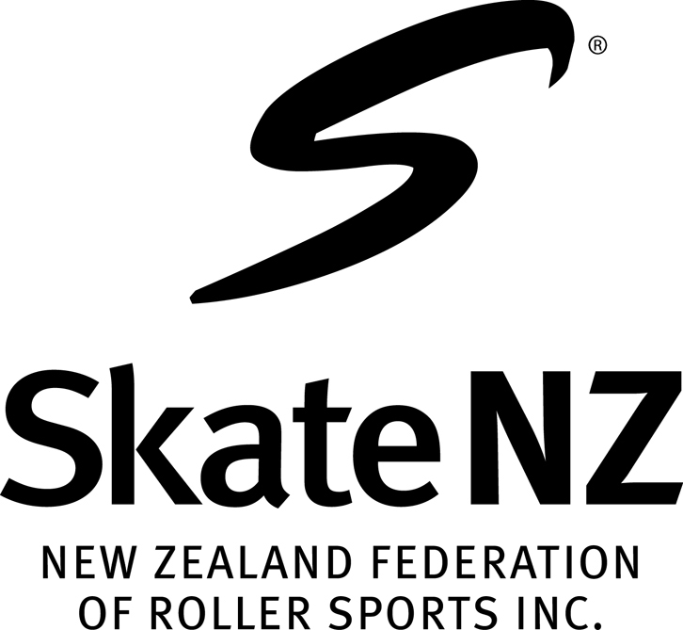
CENTRAL AREA ROLLER SPORTS COMMITTEE

CENTRAL AREA ROLLER SPORTS CHAMPIONSHIPS
ARENA 3, PALMERSTON NORTH
30th April, 1st, 2nd MAY 2021
Dear Club Secretary,

We enclose Area Championship entry forms for your club. Please ensure you return these on or before closing date of entries. Please ensure that each skater enters the correct grade, has a current SkateNZ registration number and a current Artistic number. Please ensure your members are aware that they need to be prepared to stay at least 2 nights. With the number of extra events the competition may commence Friday morning. We can not guarantee any request about day/time

ENTRY FORMS There is entry form for each skater for each discipline. Please fill these out clearly, preferably by printing. There is also a MASTER SHEET for each club to be filled in with your competitors names, in surname alphabetical order please, plus the total cost of your club’s entry fees. If posting, remember to allow 5-7 days or more for them to be received. We also require indication if a skater is planning to attend NZ Championships

ENTRY FEES $60 per skater for one event; $100 per skater for 2 or more events Family Fee $250 3 or more skaters

ENTRIES CLOSE SUNDAY 28TH MARCH 2021 AT 5:00 PM. (LATE ENTRIES WILL NOT BE ACCEPTED) with Central Area Competition Secretary, Bruce Crosby
Email brucecrosby50@gmail.com Mobile 0210645608
Postal 28 Sheridan Crescent, Trentham, Upper Hutt 5018

PAYMENT by internet or direct debited to TSB Bank 15-3950-0229267-00 Payment to be done by closing date. Please tag with club name. NO CHEQUES

SCHEDULE As per the Skate NZ Artistic Requirements 2021

FIGURE DRAW This will be sent out on the 3rd April 2021

PROGRAM CONTENT SHEETS Please ensure that Contents sheets, correctly filled in, are sent to Central Area Competition Secretary by 3rd April 2021, 5:00 pm brucecrosby50@gmail.com

PROPOSED PROGRAMME We will endeavour to have a programme to clubs approximately 10 days after entries close. If you have any special circumstances, travel or otherwise please indicate so when completing the entry form. any request cannot be guarantee to be done. once entries have closed and the organizing committee have done the order of events there will be no changes made, unless on the day by committee. Please be aware that NO CHANGES will be made to this programme. Club Roster for Officials Food will be included with this programme

MUSIC Please email all music for your events in MP3 format by 3rd April 2021, 5:00 pm to the following email nzartisticmusic@gmail.com Ensure music is correctly labelled

DISPENSATION FORMS Please use the one attached as it has been collated as one page, making it easier for use. Fill in as required. These must be sent with entries forms. Late Medical dispensations will be accepted up to the day.

CLUB TEAM MANAGER Remember you are required to elect a Team Manager for your club. A meeting will be held prior to the commencement of Areas. See separate sheet for their requirements/duties.

AREA RULES Please ensure that all skaters, parents and coaches are aware of the information contained in “Important Notice to Clubs”, especially regarding sending music and content sheets

NATIONAL ENTRY FORMS National entry forms need to be handed in at Area Championships due to the short time between closing date and Area Championships.

